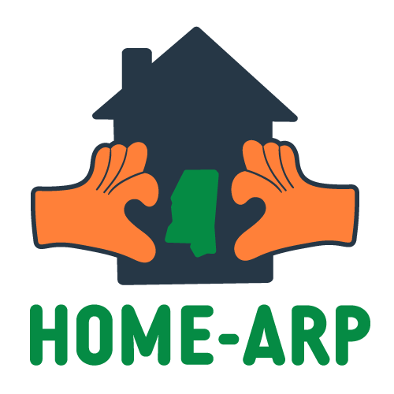

STATE OF MISSISSIPPI

**HOME-ARP ALLOCATION PLAN**

HOME INVESTMENT PARTNERSHIPS – AMERICAN RESCUE PLAN (HOME-ARP)

Date Approved by HUD:

11/18/2023

Substantial Amendment:

2/19/2025

Date Approved by HUD: TBD

Mississippi Home Corporation 735 Riverside Drive

Jackson, MS 39202

Table of Contents

Executive Summary 2

Introduction 4



Qualifying Populations 5

Eligible Activities 5

Ineligible Activities 5

Consultation 6

Summary of Consultation Process 6

Summary of Consultation Feedback 6

Public Participation 8

Efforts to Broaden Public Participation 9

Comments and Recommendations Received 9

Comments and Recommendations Not Accepted and Reasons Why 9

Needs Assessment and Gap Analysis 10

Homeless Population 10

At-risk of Homelessness 14

Fleeing or Attempting to Flee Domestic Violence, Dating Violence, Sexual Assault, Stalking or Human Trafficking 15

Other Populations 18

Unmet Housing and Service Needs of Qualifying Populations 19

HOME ARP Activities 26

HOME-ARP Housing Production Goals 29

Preferences 29

HOME-ARP Refinancing Guidelines 29

APPENDIX A: Consultation Feedback 30

APPENDIX B: Public Hearing Announcement 39

APPENDIX C: Certifications and SF-424 40

# Executive Summary

The substantial amendment of the HOME-ARP Allocation Plan includes the following:

* To amend the available funding amount from $38,094,321.00 to $36,916,321.00.
* To amend the HOME-ARP funding allocation process.
* To allow for funds not committed to other HOME-ARP activities to be moved to the HOME-ARP Supportive Services and TBRA budgets.

This Allocation Plan describes how the State of Mississippi intends to utilize funds appropriated under section 3205 of the American Rescue Plan Act of 2021 (P.L. 17-2) (ARP) for the HOME Investment Partnerships Program (HOME) to provide homelessness assistance and supportive services.

On March 11, 2021, President Biden signed ARP into law, which provides over $1.9 trillion in relief to address the continued impact of the COVID-19 pandemic on the economy, public health, state and local governments, individuals, and businesses.

To address the need for homelessness assistance and supportive services, Congress appropriated $5 billion in ARP funds to be administered through HOME to perform four activities that must primarily benefit qualifying individuals and families who are homeless, at risk of homelessness, or in other vulnerable populations. These activities include (1) development and support of affordable housing, (2) tenant-based rental assistance (TBRA), (3) provision of supportive services; and (4) acquisition and development of non-congregate shelter units.

The State of Mississippi received an allocation of ~~$38,094,321~~ $36,916,321.00 in HOME-ARP funding which will be administered by the Mississippi Home Corporation (MHC). To receive these funds, MHC must engage in consultation and public participation processes and develop a HOME-ARP allocation plan that meets the requirements established in HUD Notice CPD-21-10 and submit it to HUD as a substantial amendment to its Fiscal Year 2021 annual action plan. Upon HUD’s approval of the HOME-ARP Allocation Plan, the funds will be available for expenditure until September 2030.

To comply with the requirements of CPD-21-10, MHC developed this HOME-ARP Allocation Plan that details the consultation process, the needs assessment and gap analysis, public comments, and proposed activities for the program. MHC engaged in consultations with the Continuum of Care (CoC) agencies, stakeholders, other state participating jurisdictions, and the public via in-person meetings, virtual meetings, and surveys. In addition, MHC conducted four public hearings and accepted public comments during the planning process.

MHC utilized data from the 2020 Point in Time (PIT) count, Housing Inventory Count (HIC), 2020 Supportive Services for Veteran Families (SSVF) program data, Mississippi Parole and Reentry data, National Domestic Violence Hotline data, Mississippi Emergency Rental Assistance and Homeless Prevention data, the American Community Census data, HUD’s Public Housing data, Comprehensive Housing Affordability data, and consultations with service providers to assess the needs of the qualifying populations.

Based on consultations and data collected, there was a uniform consensus that HOME-ARP funds be used to produce affordable housing units and to develop non-congregated shelters. However, it is also noted that due to the qualifying populations that will be served with this funding, tenant-based rental

MISSISSIPPI HOME-ARP ALLOCATION PLAN

# Introduction

MHC’s HOME-ARP Allocation Plan was submitted to HUD on March 31, 2023 and approved by HUD on November 18, 2023. It describes how the State of Mississippi intends to utilize its $38,094,321 award to help qualified populations. This allocation plan has been prepared based on HUD Notice CPD-21-10 and contains the following:

|  |  |
| --- | --- |
|  |  |
| Summary of the consultation process and results of the consultation | Page 6 |
| A summary of comments received through the public participation process and a summary of any comments or recommendations not accepted and the reasons why | Page 9 |
| A description of HOME-ARP qualifying populations within the jurisdiction | Page 10 |
| An assessment of the unmet needs of each qualifying population | Page 10 |
| An assessment of gaps in housing and shelter inventory, homeless assistance and services, and homelessness prevention service delivery system | Page 10 |
| A summary of the planned use of HOME-ARP funds for eligible activities based on the unmet needs of the qualifying populations | Page 26 |
| An estimate of the number of housing units for qualifying populations the State will produce or preserve with its HOME-ARP allocation | Page 29 |
| A description of any preferences for individuals and families in a particular qualifying population or a segment of a qualifying population | Page 29 |
| HOME-ARP Refinancing Guidelines | Page 29 |
| Certifications and SF-424, SF-424B and SF-424D Forms | Page 40 |

Prior to finalizing the HOME-ARP Plan, MHC will complete each of the following processes as required by HUD Notice CPD-21-10:

## Qualifying Populations

HOME-ARP funds can only be utilized to primarily benefit “qualifying populations”. HOME-ARP defines qualifying populations as individuals or families that meet one of the following criteria:

|  |  |
| --- | --- |
| QP-1: | Homeless, as defined in section 103(a) of the McKinney-Vento Homeless Assistance Act; |
| QP-2: | At risk of homelessness, as defined in section 401 of the McKinney-Vento Homeless Assistance Act; |
| QP-3: | Fleeing, or attempting to flee domestic violence, dating violence, sexual assault, or stalking (as defined by HUD in 24 CFR 5.2003) or human trafficking (as outlined in the Trafficking Victims Protection Act of 2000 as amended [22 USC 7102]; and |
| QP-4: | Other populations, where providing supportive services or assistance under section 212(a) of the National Affordable Housing Act 42 USC 12472(a) would prevent the family’s homelessness or would serve those with the greatest risk of housing instability. |

Veterans and families that include a veteran family member that meets the criteria for one of the qualifying populations described above are eligible to receive HOME-ARP assistance.

## Eligible Activities

HOME-ARP funds may be used to benefit qualifying populations through:

1. Tenant-based Rental Assistance (TBRA)
2. Development and support of affordable housing
3. Provision of supportive services
4. Acquisition and development of non-congregate shelter
5. Nonprofit capacity building and operating assistance
6. Program planning and administration

## Ineligible Activities

HOME-ARP funds may not be used for any of the prohibited activities, costs, or fees in 24 CFR 92.214, as revised by the Appendix to Notice CPD-21-10.

# Consultation

## Summary of Consultation Process

To determine the best use of HOME-ARP funds in Mississippi and to solicit immediate feedback, MHC consulted with Balance of State Continuum of Care, Central MS Continuum of Care, Coastal Continuum of Care, homeless and domestic violence service providers, veterans’ groups, and public housing agencies that address the needs of the qualifying populations and with the Mississippi Parole Board, and public/private organizations that address fair housing, civil rights, and the needs of persons with disabilities.

Consultations were conducted between February 9, 2022, and June 30, 2022. MHC focused on gathering feedback from stakeholders through virtual surveys to generate participation. In addition to the virtual surveys, MHC conducted in-person and virtual meetings, held a homeless focus group session, and conducted presentations at the local CoC meetings. These meetings produced consultations with 78 stakeholders from the recommended entities and 321 individuals from the qualifying population. Before each session, participants were asked to complete a survey regarding the needs of their community. Surveys provided MHC with insight into the priorities of each representative and the most prevalent needs of their community. MHC presented the results of the surveys at each meeting.

All consultation meetings included an overview of the HOME-ARP notice to facilitate understanding of qualifying populations and eligible activities, an opportunity to ask clarifying questions, requests for input on needs and gaps, priority populations and activities, and an overview of the allocation plan timeline and process.

MHC accepted written comments by email and on the advisory survey throughout the planning process. Invited attendees that did not participate were directly contacted and encouraged to provide feedback. All feedback received was considered in the drafting of this allocation plan.

## Summary of Consultation Feedback

Results from the various forms of consultation revealed strong support for:

1. Capital investments in affordable rental housing include a TBRA subsidy, including permanent housing for youth aging out of foster care, domestic violence survivors, seniors ages 65 and older, and those with a criminal background.
2. Supportive services of all kinds, with specific emphasis on:
   * Employment services
   * Mental health services
   * Rental assistance
   * Life skills
3. Operating support for rental housing units developed with HOME-ARP funds

Considering priority populations, the increasing number of those with mental illness experiencing and at risk of homelessness was frequently mentioned. Other frequently cited qualifying populations and subpopulations included people with disabilities, domestic violence survivors, those recently released from incarceration, unaccompanied youth, and the chronically homeless. Due to the wide range of qualified populations suggested, the State of Mississippi will not prioritize a specific population.

Comments and feedback received during MHC’s consultation sessions are summarized as follows:

The Continuum of Cares and the Veteran Affairs Medical Center were the only stakeholders that advocated increasing shelter beds by the development of non-congregate shelters; however, without operating support and without a plan for the community to absorb the cost of operating a shelter post- HOME-ARP it would be difficult to ensure that the shelters would remain operable. Therefore, the State of Mississippi will only dedicate about 10% of HOME-ARP funds to non-congregate shelters. Many of the stakeholders including the homeless population, the CoCs, the Domestic Violence Coalition, and the VA Medical Center identified an urgent need to increase access to affordable housing through rental development. The homeless population was concerned about having affordable rental units with low barriers that will accept a homeless ex-felon, employment programs that will overlook their criminal background, and free mental health services. All three CoCs expressed their concerns about the anticipated gap in services post-ESG-CV and ERA. Some participants encouraged services to be available on-site and to include mobile outreach to meet the needs of the homeless and provide accessible wraparound services.

A listing of all consultation and feedback, including survey results, can be found in Appendix A.

# Public Participation

MHC published an announcement of all scheduled public hearings on its website at [www.mshomecorp.com](http://www.mshomecorp.com/) on July 21, 2022. The announcement (Appendix B) outlined the dates, times, and locations of all four public hearings. In addition, MHC released a draft of the HOME-ARP Plan on its website on August 15, 2022.



The purpose of these public hearings was to encourage citizen participation in the development of the HOME-ARP Allocation Plan. MHC was required to hold at least one public hearing; however, to engage as much participation from the public as possible, MHC elected to host three in-person meetings and one virtual meeting.

During each meeting, MHC made the following information available to the public:

* The amount of HOME-ARP funds received
* The range of activities that MHC may undertake
* The public comment period start and end dates
* The various methods the public may submit their comments

MHC distributed an information bulletin to all individuals on its email distribution list, all three CoCs, and all ESG service providers notifying them of the opportunity to participate in our virtual or in-person consultation sessions held in 2022. For those who were not able to participate in the consultation sessions, MHC enlisted feedback through an informational survey regarding HOME-ARP and community needs. This survey was sent to all public housing authorities and community leaders. In addition, MHC provided a 15-day public comment period beginning August 16, 2022, through September 15, 2022. MHC conducted a total of four (4) public hearings in areas that were identified in the data as having high homeless numbers, poverty rates, and an increased percentage of the at-risk homeless population.

Held Public Hearings

August 16, 2022 Cleveland

August 18, 2022 Gulfport

August 25, 2022 Tupelo

August 26, 2022 Virtual (for individuals located in central Mississippi)

These locations were chosen based on the CoC, the count, and the poverty rate of those communities.

A combined notice of the public comment period and public hearing dates were published in newspapers across the state. In addition, the public notice was posted on MHC’s website and an information bulletin notifying stakeholders and the public was distributed to MHC’s and the CoC’s mailing list.

## Efforts to Broaden Public Participation

To broaden public participation, members of the public who are on the MHC email list were invited to attend the consultation sessions held in the formulation of the Allocation Plan. Additionally, outreach to key stakeholders was conducted from January 2022 to September 2022. MHC’s outreach included intentional outreach to homeless service providers, developers, Continuum of Cares, veteran's service providers, Domestic Violence Coalition and service providers, individuals with lived experience, community advocates, and disability service advocates. MHC consulted with 73 stakeholders representing a variety of services provided throughout the state. Consultations consisted of in-person meetings, virtual meetings, written and verbal comments, surveys, and a focus group consisting of 31 homeless individuals. In each session, participants were encouraged to provide comments. Additionally, participants were requested to use a survey to provide information regarding community needs and recommendations for HOME-ARP.

## Comments and Recommendations Received

A summary of comments and recommendations received during the public comment period and at the public hearing is included in **Appendix A.**

## Comments and Recommendations Not Accepted and Reasons Why

A summary of comments and recommendations received but not accepted and the reasons why is included in **Appendix A.** Most of the comments and recommendations provided during the advisory meetings and the public comment period were accepted; however, a few recommendations were not accepted.

**Recommendation 1:** The City of Jackson recommended that MHC layer its HOME-ARP NCS funds with their NCS funds to allow for NCS development in Jackson.

**Why Recommendation was Not Accepted:** The request that MHC funds be allocated and layered with City of Jackson funds were not accepted because the needs assessment, CoCs’ input, and surveys all point to the need of NCS in all three CoCs and not just in Jackson.

**Recommendation 2:** Can MHC allocate funds for operation and furniture purchase in NCS?

**Why Recommendation was Not Accepted:** It is against HOME-ARP regulations for NCS funds to be used for shelter operation expenses.

# Needs Assessment and Gap Analysis

MHC was required to evaluate the size and demographic composition of HOME-ARP qualifying populations and identify the unmet needs of qualifying populations. In addition, the needs assessment and gap analysis must identify any gaps within its current shelter and housing inventory, and service delivery system. This needs assessment and gap analysis focus on:

1. Sheltered and unsheltered homeless populations
2. Currently housed populations at risk of homelessness
3. Other families requiring services or housing to prevent homelessness
4. Those at greatest risk of housing instability or unstable housing situations

MHC evaluated the size and demographic composition of the qualifying populations and assessed the unmet need of each population.

**Gap Analysis: Sheltered and unsheltered homeless populations Homeless Population**

The McKinney-Vento Homeless Assistance Act defines homelessness in four categories: 1) An individual or family who lacks a fixed, regular, and adequate nighttime residence, or 2) an individual or family who will imminently lose their primary nighttime residence, or 3) unaccompanied youth under 25 years of age, or families with children and youth, who do not otherwise qualify as homeless under this definition, or 4) individuals fleeing or attempting to flee domestic violence. Domestic Violence is further defined as individuals fleeing or attempting to flee dating violence, sexual assault, stalking, or human trafficking.

Point in Time Count (PIT)

Due to the coronavirus pandemic, there was no street count conducted in 2021 to identify unsheltered homeless populations. The January 2020 PIT count of both sheltered and unsheltered homelessness was used for this analysis. In 2020 a total of 1,107 individuals from 922 households were identified as homeless.

Housing Inventory Count (HIC)

The annual Housing Inventory Count (HIC) provides useful context regarding the number and type of beds and units that are available for individuals and families experiencing homelessness on any given night. Table 1 summarize beds and units available as of January 2020 in the State of Mississippi by bed type.

Emergency housing beds include emergency shelter and transitional housing; emergency shelter generally allows for short-term or nightly stays, while transitional housing generally allows for a stay up to 24 months. Both types of emergency housing may include supportive services designed to facilitate movement to independent living.

MISSISSIPPI HOME-ARP ALLOCATION PLAN

Rapid rehousing provides security and utility deposits and/or monthly rental and utility assistance for rental units that rent for less than the fair market rent. Assistance is generally provided for the shortest period necessary for a household to gain stable housing and can range from 3 to 24 months. Permanent supportive housing provides for an unlimited lease term; residents receive services necessary to promote continued housing stability.

Table 1: Homeless Needs Inventory and Gap Analysis Table

|  |  |  |  |  |  |  |  |  |  |  |  |  |  |
| --- | --- | --- | --- | --- | --- | --- | --- | --- | --- | --- | --- | --- | --- |
| **HOMELESS** | | | | | | | | | | | | | |
|  | Current Inventory | | | | | Homeless Population | | | | Gap Analysis | | | |
| Family | | Adults Only | | Vets | Family HH (at least 1 child) | Adult HH  (w/o child) | Vets | Victims of DV | Family | | Adults Only | |
| # of Beds | # of Units | # of Beds | # of Units | # of Beds | # of Beds | # of Units | # of Beds | # of Units |
| Emergency Shelter | 277 | 71 | 239 | 0 | 2 |  |  |  |  |  |  |  |  |
| Transitional Housing | 191 | 71 | 233 | 0 | 30 |  |  |  |  |  |  |  |  |
| Permanent Supportive Housing | 685 | 456 | 225 | 0 | 99 |  |  |  |  |  |  |  |  |
| Other Permanent Housing (RRH) | 723 | 249 | 110 | 0 |  |  |  |  |  |  |  |  |  |
| Sheltered Homeless |  |  |  |  |  | 75 | 325 | 37 | 97 |  |  |  |  |
| Unsheltered Homeless |  |  |  |  |  | 1 | 516 | 31 | 20 |  |  |  |  |
| ***Current Gap*** |  |  |  |  |  |  |  |  |  | **0** | **0** | **407** | **407** |

**Data Source:** 1. Point in Time Count (PIT); 2. Continuum of Care Housing Inventory Count (HIC): 3. Consultation

Table 2: Point-in-Time Count (PIT)

|  |  |  |  |  |
| --- | --- | --- | --- | --- |
| **Summary of Persons in Each Household (HH) Type** | | | | |
|  | Emergency Shelter | Transitional Housing | Unsheltered | Total |
| **Persons in HHs w/o children** | **208** | **118** | **522** | **848** |
| *Persons 18 – 24 yrs old* | 15 | 11 | 21 | 47 |
| *Persons over 24 yrs old* | 193 | 107 | 501 | 801 |
| **Persons in HHs with at least one adult and one child** | **119** | **131** | **4** | **76** |
| *Children under 18 yrs old* | 74 | 83 | 3 | 160 |
| *Persons 18 -24 yrs old* | 1 | 5 | 0 | 6 |
| *Persons over 24 yrs old* | 44 | 43 | 1 | 88 |

|  |  |  |  |  |
| --- | --- | --- | --- | --- |
| MISSISSIPPI HOME-ARP ALLOCATION PLAN | | | | |
| **Persons in HHs with only children** | **5** | **0** | **0** | **5** |
| **Total** | **332** | **249** | **526** | **1,107** |

Table 3: Housing Needs Inventory and Gap Analysis Table

|  |  |  |
| --- | --- | --- |
| **NON-HOMELESS** | **Current Inventory** | **Level of Need** |
| # of Units | # of Households |
| Total Rental Units | 348,677 |  |
| Rental Units Affordable to HH at 30% AMI (At-Risk of Homelessness) | 85,455 |  |
| Rental Units Affordable to HH at 50% AMI (Other Populations) | 61,830 |  |
| 0%-30% AMI Renter HH w/ 1 or more severe housing problems (At-Risk of Homelessness) |  | 98,865 |
| 30% - 50% AMI Renter HH w/ 1 or more severe housing problems (Other Populations) |  | 79,390 |

**Data Source:** Comprehensive Housing Affordability Strategy (CHAS)

Substandard Housing Data:

|  |  |
| --- | --- |
| **Selected Characteristics** | |
| Occupied housing units | 1,116,649 |
| Lack of completed plumbing | 5,157 |
| Lack of completed kitchen | 8,075 |

**Data Source:** 2020 ACS 5-year estimates— S2504 PHYSICAL HOUSING CHARACTERISTICS FOR OCCUPIED HOUSING UNITS

Unsheltered Homeless Populations

The 2020 unsheltered PIT count identified 526 people in 517 households experiencing unsheltered homelessness on January 22, 2020. People are considered unsheltered when they are residing in a place not meant for human habitation as defined in category one of the homeless definitions. Among individuals experiencing unsheltered homelessness:

* 502 were over the age of 24; 21 were ages 18 to 24, and 3 were under the age of 18
* 392 identified as male, 132 identified as female, 2 identified as transgender, and 0 identified as gender non-conforming

MISSISSIPPI HOME-ARP ALLOCATION PLAN

* 515 identified as non-Hispanic, 11 identified as Hispanic, 278 identified as White, 8 identified as Native American, 15 identified as multiple races, 219 identified as Black or African American, 8 identified as Asian, and 5 identified as Native Hawaiian or Other Pacific Islander
* 104 met the definition of experiencing chronic homelessness
* 141 were adults with a serious mental illness
* 86 were adults with a substance use disorder
* 4 were adults with HIV/AIDS
* 20 were adult survivors of domestic violence
* 20 were Veterans Sheltered Homeless Population

The 2020 sheltered PIT count identified 581 people in 405 households experiencing sheltered homelessness on January 22, 2020. People are considered sheltered when they are residing in an emergency shelter or transitional housing, but not when they are receiving rapid rehousing assistance or residing in permanent supportive housing. Among individuals experiencing sheltered homelessness:

* 387 were over the age of 24; 32 were ages 18 to 24, and 162 were under the age of 18
* 317 identified as male, 263 identified as female, 1 identified as transgender, and 0 identified as gender non-conforming
* 574 identified as non-Hispanic, 7 identified as Hispanic, 234 identified as White, 3 identified as Native American, 7 identified as multiple races, 335 identified as Black or African American, 2 identified as Asian
* 42 met the definition of experiencing chronic homelessness
* 66 were adults with a serious mental illness
* 126 were adults with a substance use disorder
* 23 were an adult with HIV/AIDS
* 97 were adult survivors of domestic violence
* 37 were Veterans

It is critical to note that the experience of homeless is disproportionally higher among Black/African American Mississippians. In 2020 Black/African American Mississippians represented 50% of those experiencing homelessness as compared to only accounting for 37% of the general state population in 2020.

The 2020 PIT count results estimated a total of 1,107 Mississippians experiencing homelessness. While the Balance of State is home to most individuals counted as sheltered or unsheltered homeless during the PIT count, the Central CoC has the highest concentration of homeless in one city. The Balance of State covers 72 rural counties and has pockets of homeless identified in 20 counties. The Balance of State homeless county PIT count ranges from one homeless individual to 121 homeless individuals.

MISSISSIPPI HOME-ARP ALLOCATION PLAN

According to the data, Mississippi does not need family shelter beds. Looking specifically at those who experience sheltered and unsheltered homelessness, it is estimated that 407 individuals require intervention to exit homelessness through a supportive service program or access to affordable housing units. The state estimated that supportive housing programs house 1859 households per year through RRH and PSH programs, leaving 246 on the Coordinated Entry System list waiting on housing. Coordinated Entry System waitlist numbers were not provided by the BoS.

The data does not support a statewide need for creating congregate and non-congregate shelters. The HIC data revealed that some areas in the state have an abundance of family shelter beds and no individual shelter beds. More specifically, in 2020, the Gulf Coast CoC identified 53 family shelter beds and only 9 single adult beds. That year the Gulf Coast CoC identified 186 unsheltered homeless individuals. Additionally, comparing the PIT data and the HIC data over the past three years, it is noted that three communities (Hinds County, Gulf Coast MS, and Forrest County) can identify a gap in shelter beds due to their unsheltered homeless population.

The data supports a need for 407 additional shelter beds for individuals.

**Gap Analysis: Currently housed populations at risk of homelessness At-risk of Homelessness**

The McKinney-Vento Homeless Assistance Act defines at risk of homelessness as those with incomes below 30% AMI that lack sufficient resources or support networks to prevent homelessness, and 1) have moved more than two times due to economic reasons in the past 60 days, or 2) are doubled up with another household due to economic hardship, or 3) will be evicted within 21 days, or 4) live in a hotel or motel without financial assistance from a nonprofit or government entity, or 5) live in an efficiency apartment and are overcrowded, or 6) are exiting a publicly-funded institution or system of care.

The 2020 Coordinated Entry homeless program data provided by the local CoCs indicates that approximately 5% of individuals exiting emergency shelters, transitional, and permanent housing returned to homelessness within 12 months.

At greatest risk of housing instability are those households with incomes less than 30% AMI and experiencing severe housing cost burden.

On September 29, 2021, HUD released updated Comprehensive Housing Affordability Strategy (CHAS) data for the 2014-2018 period. It is important to notate that these are pre-Covid data figures, and the data was pulled from the 2014-2018 CHAS report as recommended by HUD. According to the 2020 National Low-Income Housing Coalitions report on 2020 American Census 5-year data, there is a need for 48,005 affordable rental units in Mississippi. This is a 10k unit increase from 2014-2018 data. In 2020, the pandemic brought on significant housing challenges. Renters were disproportionately impacted by the pandemic financially due to having jobs that faced the most layoffs and furloughs. The rise in unemployment and loss of income caused Congress to enact much-needed assistance through the CARES Act of 2020 and the Consolidated Appropriations Act of 2021. These funding sources allowed MHC to launch the Emergency Rental Assistance Program (RAMP) and the Emergency Solutions Grant CARES

MISSISSIPPI HOME-ARP ALLOCATION PLAN

Act Program (ESG-CV) to provide housing assistance to households in Mississippi. However, these are short-term programs that will phase out by 2023 leaving a gap in needed resources in a state impacted by poverty, lack of affordable housing, and feeling the ripple effects post-COVID.

The 2014-2018 HUD CHAS data provides information on households’ income levels and housing problems. This CHAS data indicates there are approximately 79,390 households with incomes between 30% and 50% AMI that are at risk of homelessness in Mississippi.

The American Community Survey provided 2020 housing instability data revealing there are 150,617 renter households in Mississippi with annual income less than 30% AMI that has the greatest risk of housing instability. In addition, in 2020 a total of 20,437 households with income less than 50% AMI sought assistance through the Emergency Solution Grant-COVID (ESG-CV) and the Emergency Rental Assistance (ERA) programs.

|  |  |
| --- | --- |
| **Overburden Data** | |
| Gross Rent as a Present of Income | Statewide |
| Cost burden: 30% to 50% | 71,993 |
| Severely Cost burden: 51% or more | 72,450 |
|  | 144,443 |

**Data Source:** 2020 ACS 5-year estimates B25070 GROSS RENT AS A PERCENTAGE OF HOUSEHOLD INCOME IN THE PAST 12 MONTHS

|  |  |  |  |
| --- | --- | --- | --- |
| **At Risk of Homelessness** | | | |
|  | Households receiving ESG-CV | Households receiving ERA | Total |
| *30% AMI* | 685 | 19752 | 20,437 |
| *50% AMI* | 135 | 9125 | 9,260 |
| *80% AMI* | 56 | 5618 | 5,674 |
| **Total** | **876** | **34,495** | **35,371** |

## Fleeing or Attempting to Flee Domestic Violence, Dating Violence, Sexual Assault, Stalking, or Human Trafficking

Domestic violence and human trafficking are defined in 24 CFR5.2003 and the Trafficking Victims Protection Act of 2000 as fleeing/attempting to flee domestic violence, dating violence, sexual assault, stalking, or human trafficking. The human trafficking definitions includes both sex trafficking and labor trafficking.

The 2020 PIT identified 97 sheltered adult and 20 unsheltered adult survivors of domestic violence. The count of sheltered and unsheltered survivors of domestic violence does not include children in families. Providers of services to domestic violence survivors indicate the number of individuals in need of shelter

MISSISSIPPI HOME-ARP ALLOCATION PLAN

is likely low due because isolation and physical distancing mandates often resulted in increased domestic violence concerns which limits a victim’s potential flight from the unsafe living situation. The 2020 PIT count only consists of data from Domestic Violence Shelters; however, data was collected from the Domestic Violence Hotline. According to the Domestic Violence hotline data, there were 503 calls made to the hotline with 14% of those calls coming in from the City of Jackson. According to the research, individuals in a domestic abusive home may not escape if they do not have somewhere to go. Additionally, in Mississippi, there are domestic violence shelters but there are no set aside affordable units just for domestic violence survivors.

**Gap Analysis: Those at greatest risk of housing instability or unstable housing situations Greatest Risk of Housing Instability Due to Cost Burden**

In Mississippi, more than 41% of renters are living with a housing cost burden as defined by HUD where rent charges are more than 30% of total income, and 21% of households live with a severe cost burden which is defined as rent being more than 50% of total income. Additionally, Mississippi has the highest poverty level in the nation where 19.6% of its residents are living below the poverty line according to US Census Bureau table S1901. The poverty rates and cost burden in the state point to the need for affordable housing.

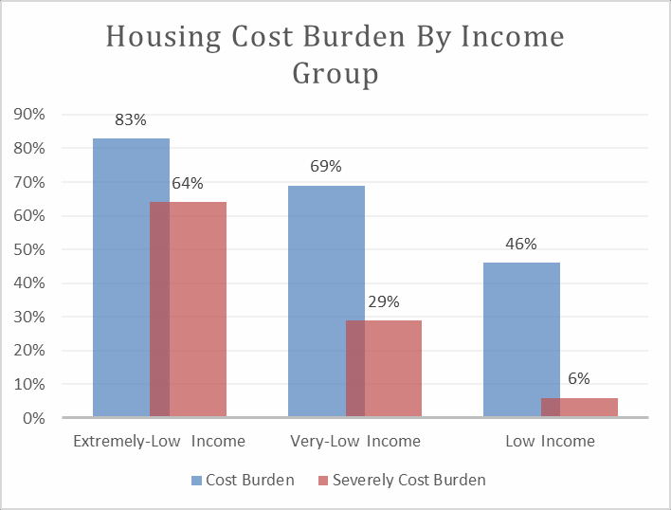

It is evident in the data that the cost burden in Mississippi combined with poverty is putting many Mississippians at great risk of experiencing homelessness or being evicted. The advisory surveys and information sessions conducted to gather input regarding the community need overwhelmingly pointed

MISSISSIPPI HOME-ARP ALLOCATION PLAN

to a need for more affordable rental housing. The state will use collected data to dictate where affordable housing should be located. As illustrated below, traditionally low-income housing developments were not always placed where there were high evictions and increased homeless numbers.

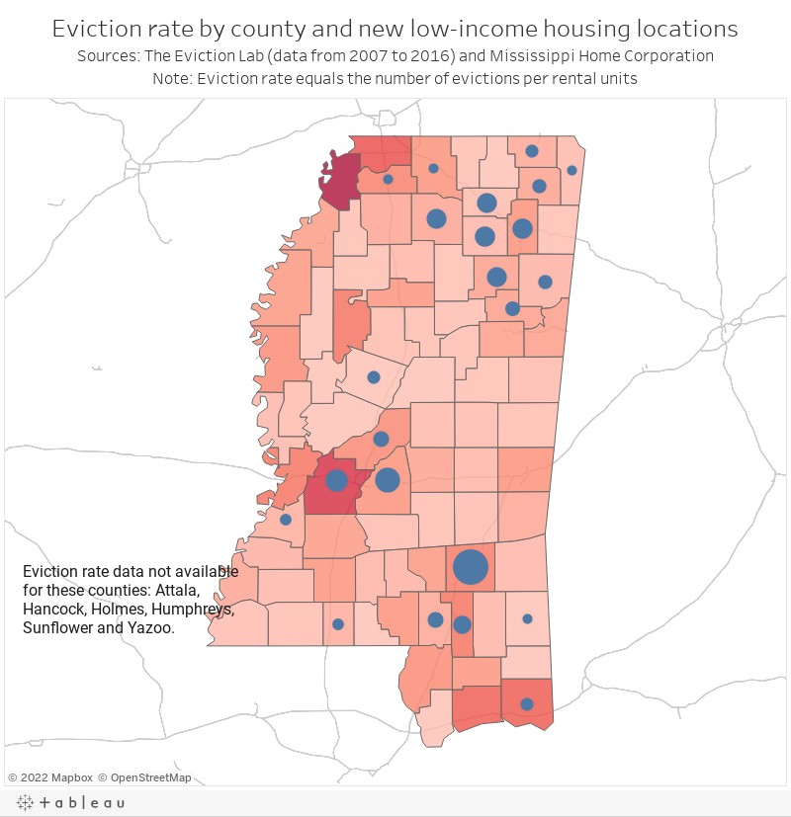

**Gap Analysis: Other Families Requiring Services or Housing to Prevent Homelessness Other Populations**

Reentry Population

Secretary Fudge's national address on June 3, 2021, identified the need for more housing services to be targeted toward the reentry population using the American Rescue Plan program to leverage services to the reentry population.

In Mississippi, the data points to a need for housing and services to be targeted toward the reentry population. According to the data, 450 inmates were paroled with no place to live. Additionally, 10,000 are eligible for parole in Mississippi and many of these individuals cannot be paroled due to a lack of housing.

Youth and Families Seeking Reunification Population

In 2010, HUD issued a challenge for communities to develop a plan and put an effective end to homelessness. Ending homelessness was described through four subpopulations: 1) Veterans, 2) chronic homelessness, 3) families, and 4) youth. Homelessness among youth may be experienced through family homelessness and domestic violence, which includes sex trafficking, runaway, or aging out of foster care. When young adults age out, often around 18 years old, it means that they are leaving the foster care system without having been placed in a permanent family or home. They weren’t re-united or adopted; they basically just “timed out.”

Nationally, 20% of children who transition out of foster care will experience homelessness before the age of 21. In Mississippi, according to the Mississippi Youth in Transition (MS-YIT) 2023 report, 52% of youth that responded to the MS-YIT survey indicated that most nights, they were not sure where they would sleep. Additionally, 27% of children in Mississippi live in households with high housing cost burdens. Two counties in the State of Mississippi have secured housing resources through the Foster Youth Initiative vouchers; however, other housing resources for homeless youth and families are limited.

### Identify and consider the current resources available to assist qualifying populations, including congregated and non-congregate shelter units, supportive services, TBRA, and affordable and permanent supportive rental housing:

## Unmet Housing and Service Needs of Qualifying Populations

The greatest unmet housing needs of qualifying populations are:

* Permanent rental housing that is affordable to qualifying and other populations
* Permanent supportive rental housing that coordinates housing with TBRA for qualifying and other populations
* Permanent rental housing that coordinates with supportive services The greatest unmet service needs of qualifying populations are:
* Job training programs
* Mental health and substance abuse services
* Legal services
* Utility assistance
* Case Management

Additional unmet service needs of qualifying populations include the following as described in HUD CPD Notice 2021-10, as may be amended:

* Financial assistance to secure stable housing, such as rental application fees, security, and

utility deposits, and first and last month’s rent

* Education programs
* Life skills

Congregate Beds Shelter Units

According to the 2020 CoC HIC Report, Mississippi has 31 agencies that provide emergency shelter, transitional housing, and safe-haven shelter beds throughout the state. This includes 962 transitional housing and shelter beds. According to the data, there were shelter beds lost in each CoC due to COVID. The BoS CoC lost a total of 110 transitional housing and shelter beds, the Central CoC lost a total of 53 beds, and the Gulf Coast CoC had a reduction of 60 beds in their CoC area. The shelter bed numbers do not include RRH program beds. On average, Mississippi has about 760 RRH beds which include Supportive Services for Veterans and their Family (SSVF) and CoC RRH beds. In 2020 alone, ESG-CV provided an increase in 169 RRH to those who were homeless.

Supportive Services

Mississippi is a largely rural state consisting of 82 counties with 65 counties meeting the definition of rural. In Mississippi, many rural and urban areas are considered food and resource deserts. Additionally, the scarce supportive services are inconsistent. Urbanized and higher-density areas have a wider range of services while rural, lower-density, and/or more isolated areas have limited-service availability.

Tenant-based Rental Assistance

There are fifty-two housing authorities located throughout Mississippi. The PHAs administer the Section

8 Housing Choice Voucher program which includes Emergency Housing Vouchers. There are approximately 5,021 regular vouchers, 492 HUD-VASH vouchers, and 381 Emergency Housing Vouchers (EHV).

Currently, there are waitlists for all Housing Authorities Section 8 Housing Choice Vouchers in Mississippi. However, there are available vouchers in select programs. HUD-VASH has 109 vouchers not used and EHV has 108 vouchers currently not issued. Counties in Mississippi that are not at full capacity for their EHV are mainly in the delta region of the state. The delta is reported to have high poverty rates and limited rental housing availability.

HOPWA vouchers are available throughout the state. The state currently has two agencies administering a total of 185 HOPWA vouchers.

The State of Mississippi received an $18 million increase in RRH services through the ESG-CV grant. Despite the increase in RRH funds, the availability of housing vouchers, affordable housing units, supportive services, and affordable housing is very difficult, and many individuals are required to go on a waitlist. As of July 31, 2022, the state had 246 individuals on the Coordinated Entry System wait list (CES numbers not provided by the BoS). Applicants to the RRH programs can receive up to 24 months of assistance; however, many individuals in the housing program are unable to obtain housing stability or remain on the waitlist due to limited access to affordable housing.

Affordable and Permanent Supportive Rental Housing

For the operating year of 2020, there were an estimated 32,119 HUD/Treasury affordable rental housing units with 66 in HOME development, 53 in HTF, and about 32,000 LIHTC units in Mississippi. In January 2020, there were 910 permanent supportive housing beds.

### Identify any gaps within the current shelter and housing inventory as well as the service delivery system:

Shelter Gap Methodology

The shelter gap in Mississippi is sporadic and not consistent with the homeless population's location. More than 75% of counties in Mississippi do not have an emergency shelter. Additionally, there are very few low barrier shelters whereas many shelters in the state have requirements to enter the facility or are dedicated to victims of domestic violence. The unsheltered homeless rate of 47% and the limited access to shelter beds for single individuals signifies a gap in safe and welcoming emergency shelter beds in Mississippi. Additionally, many of the current shelters operating do not have separate (non-congregate) sleeping quarters for individuals.

The shelter gap methodology utilized the January 2020 point-in-time count of sheltered individuals, individuals in families and the CoC Housing Inventory Count for 2020, the seven-day homeless count as of June 30th, 2022, and the recurrent homeless count. The estimated homeless count was compared to the average shelter beds that were reported in 2018-2020. The formula to calculate the estimated homeless count and shelter bed gap was built upon the CSA Estimating the Need Methodology.

Formula: A + ((B * 51) * (1-C)) = annual estimate 1,107+((38*51)*(1-.05)= 2,945.1

(annual estimate) - (annual average of individual shelter beds) = shelter gap 2,945.1 – 1,136= 1,812.

Where:

* A = PIT count of currently homeless (CH) people – including adults and children, and don’t forget to take out the people you counted who live in PSH
* B = number of CH adults and children who 1) became homeless within the last 7 days, whether for the first time or not, or 2) were already homeless, but just entered the boundaries of your community within the past 7 days
* C = proportion (expressed in decimals – i.e., 15% = .15) of CH adults and children in A who have had a previous homeless episode within the past 12 months. It is important to understand what this formula says. “B” and “(B*51)” – this part of the formula asks you to supply the number of people whose current homeless spell began within the past 7 days, or who, though homeless already, just came within your community’s boundaries within the past 7 days ([Burt & Watkins, 2005)](https://www.csh.org/wp-content/uploads/2013/08/Estimating-the-Need.pdf).

It is noted that the number of beds needed throughout the year is high because the data is considering nightly needs for one year based on the number of individuals entering the CES each week.

Affordable and Permanent Supportive Rental Housing Gap

|  |  |  |  |
| --- | --- | --- | --- |
| **NON-HOMELESS** | | | |
|  | **Current Inventory** | **Level of Need** | **Gap Analysis** |
| # of Units | # of Households | # of Households |
| Total Low-Rental Units through the Housing Authority | 8,268 |  |  |
| LIHTC | 32,000 |  |  |
| LIHTC 30% AMI (At-Risk of Homelessness) | 439 |  |  |
| LIHTC 50% AMI (Other Populations) | 3227 |  |  |
| HOME | 121 |  |  |
| Total number of individuals at risk of homelessness with a Cost Burden of 30% AMI |  | 71,993 |  |
| Total number of individuals at risk of homelessness with a Cost Burden of 50% AMI |  | 72,450 |  |
| ***Current Gaps*** |  |  | **-135,293** |

Data Source: PUBLIC HOUSING (PH) DATA DASHBOARD 2022; Low Income Housing Tax Credit data 2020, 2020 ACS 5-year estimates DP05 and B25070 GROSS RENT AS A PERCENTAGE OF HOUSEHOLD INCOME IN THE PAST 12 MONTHS

In the state of Mississippi, there are 8,268 low-rent units through the Housing Authority, 121 units through HOME, and 32,000 Low-Income Housing Tax Credit units. Tax Credit units consists of 80% AMI to 30% AMI. Out of the 32,000 LIHTC units, only 3,666 are dedicated to those whose household income is 50% or below AMI. Currently, Mississippi has a 95% occupancy rate for HUD housing units.

There is an estimated gap of 135,293 rental units affordable to renter households with income less than 50% AMI in Mississippi.

Affordable and Permanent Supportive Rental Housing Gap Methodology

The number of Affordable Rental Units was calculated using data from the Public Housing Data dashboard 2022, Low Income Housing Tax Credit, and the 2020 American Community Survey 5-Year Estimates Table B2570 and DP05.

Service Delivery System Gaps and Methodology

Given the extensive rurality of Mississippi, the service delivery system has become strained and highly variable leaving gaps in supportive service delivery throughout the state. To identify gaps in the service delivery system, MHC consulted with stakeholders including individuals currently experiencing homelessness and drew on its experience working with organizations statewide. Consultation with stakeholders revealed numerous service delivery system gaps including employment programs and case management, connecting individuals and families to employment opportunities with sufficient income to afford housing, too few affordable rental units in general, programs to help the reentry population, move-in assistance, mental health services accessible to the homeless, substance abuse programs for the homeless, landlord outreach and liaison services. It was noted that about 20% of homeless individuals reported having a disabling condition; however, according to SAGE, only 19.8% of those disabled are connected to disability income. In addition, stakeholders discussed challenges in securing consistent operating funds for general administrative costs and building capacity to undertake development activities.

Finally, street outreach efforts have increased tremendously with funds provided through ESG-CV. The ESG-CV funds will expire in September 2023 which will create a gap in identifying and connecting unsheltered homeless individuals to supportive services and rental assistance programs.

Characteristics of Housing Associated with Increased Risk of Homelessness for Other Populations

For other populations, severe housing cost burden, or paying more than 50% of household income for rent and utilities is the primary characteristic of housing associated with increased risk of homelessness throughout Mississippi.

Priority Needs for Qualifying Populations

Priority needs for qualifying populations are:

* + Affordable rental housing, including permanent supportive housing
  + Non-congregate shelter
  + Supportive services including:
    - Housing navigation
    - Case management
    - Education services
    - Employment assistance and job training
    - Housing search and counseling assistance
    - Coordinated service linkage
    - Legal services
    - Life skills training
    - Mental health services
    - Outpatient health services
    - Outreach services
    - Substance abuse treatment services
    - Landlord-tenant liaison services
    - Services for special populations, including trauma-informed services
    - Financial assistance to secure stable housing, such as rental application fees, security

and utility deposits, and first and last month’s rent

### Identify the characteristics of housing associated with instability and an increased risk of homelessness if the PJ will include such conditions in its definition of “other populations” as established in the HOME-ARP notice:

The state considered renters' cost burden and substandard housing conditions when considering characteristics of housing instability*.* According to the 5-year 2020 American Community Survey, 144,443 Mississippi renters reported having a cost burden of 30% or more. The high-cost burden in Mississippi is linked to the state’s poverty rate. Mississippi has the highest poverty level in the nation with 20.3% of its residents living below the poverty line according to Forbes.

In addition to the cost burden, some Mississippi renters are living in substandard housing. HUD’s Comprehensive Housing Affordability Strategy 2014- 2018 (CHAS) data reports that 178,255 Mississippi renter households have at least one of the four severe housing problems. Additionally, the 5-year 2020 American Community Survey reported that 13,232 Mississippians' housing lack a completed kitchen or completed plumbing. These households lack safe, economically sustainable housing and are at an increased risk of housing instability and homelessness. Therefore, households that spend more than 30% of their income and live in substandard housing are considered unstable housed and at risk of homelessness.

### Identify priority needs for qualifying populations:

Mississippi does not have a shelter or access to shelter beds which led to a shelter gap, not in shelter beds in the state, but in shelter access. In addition to limited access to shelter beds across the state, the gap analysis, public hearings, and advisory meetings all identified a gap in affordable housing units. Mississippi data revealed a gap of 135,293 affordable housing units across the state. The affordable housing burden is elevated when considering that 21% of all Mississippi renters are paying more than 50% of their income towards rent which puts those households at risk of homelessness. The state’s plan to use HOME-ARP funds for NCS to increase affordable housing and supportive services will address the identified needs for shelter and affordable housing. Furthermore, supportive services and TBRA programs will help increase housing sustainability and reduce the housing burden faced by qualified populations.

### Explain how the level of need and gaps in its shelter and housing inventory and service delivery systems based on the data presented in the plan were determined:

The data analysis is addressed previously in this plan. MHC pulled from resources recommended by HUD including the 2020 American Community Survey 5-year data, Comprehensive Housing Affordability Strategy, Public Housing (PH) Data Dashboard 2022, Emergency Housing data, Point in Time count, Housing Inventory Data, and data pulled from the Homeless Management Information System (HMIS). The state used the Cooperation for Supportive Housing (CSH) Estimating the Need formula was used to calculate the expected homeless count. This formula was transferred to identify the shelter gap.

# HOME ARP Activities

### Describe the method for soliciting applications for funding and/or selecting developers, service providers, sub-recipients, and/or contractors and whether the PJ will administer eligible activities directly.

MHC will solicit applications for the HOME-ARP development activities from developers, service providers, and/or non-profit organizations who have prior experience developing non-congregate shelters (NCS) and/or with developing affordable rental housing. Applications for NCS acquisition only projects will be accepted from organizations who have prior experience in operating a shelter. Additionally, applications will be accepted from all eligible organizations for supportive services and TBRA services with a recommendation for partnerships between developers and service providers. Organizations eligible to receive funding through the HOME ARP program are non-profit and for-profit organizations with demonstrated development and capacity in creating, rehabilitating, or preserving affordable housing. Eligible entities will be required to ~~complete a~~ demonstrate development experience.

~~A Notice of Funding Availability (NOFA) will be issued. The NOFA will, at a minimum, specify eligible applicants, eligible activities, minimum and maximum funding amounts, application threshold and scoring criteria, as well as underwriting criteria, and will provide instructions on how to apply.~~

Mississippi Home Corporation (MHC) will provide HOME-ARP subawards through an MHC approved process. Agencies selected for a HOME-ARP subaward must have experience with managing federal or state funds. MHC will ~~leverage Tax Credit and HOME funding~~ allow HOME-ARP projects to leverage funds with other resources (HOME, HTF, LIHTC) to increase development production. The Tax Credit Qualified Allocation Plan (QAP) did not identify NCS as an activity; therefore, Tax Credit resources will not be used towards NCS. ~~The amount and production goals of Tax Credit and HOME leveraged funds will not be described in this plan.~~

MHC will not directly administer HOME-ARP activities beyond program administration and planning and no sub-recipients or contractors are responsible for program administration and planning on behalf of the state.

### If any portion of the PJ’s HOME-ARP administrative funds were provided to a sub-recipient or contract prior to HUD’s acceptance of the HOME-ARP allocation plan because the sub-recipient or contractor is responsible for the administration of the PJ’s entire HOME-ARP grant, identify the sub-recipient or contractor and describe its role and responsibilities in administering all the PJ’s HOME-ARP program:

The state did not allocate funds to a sub-recipient or contractor to administer the entire HOME-ARP grant.

Use of HOME-ARP Funding

Table 4: Breakdown of Allocated Funds by Activity

|  |  |  |  |
| --- | --- | --- | --- |
| **Activity** | **Funding Amount** | **Percent of Allocation** | **Statutory Limit** |
| Supportive Services | $5,714,149.00 |  |  |
| Development of Non-congregate Shelter | $3,714,196.00 |  |  |
| Tenant-based Rental Assistance | $7,714,100.00 |  |  |
| Development of Rental Housing | $11,428,296.00 |  |  |
| Non-profit Operating | ~~$1,904,716.00~~  $1,355,716.00 | ~~5%~~  4% | ~~5%~~  4% |
| Non-profit Capacity Building | ~~$1,904,716.00~~  $1,355,716.00 | ~~5%~~  4% | ~~5%~~  4% |
| Administration and Planning | ~~$5,714,148.00~~  $5,634,148.00 | 15% | 15% |
| **Total HOME-ARP Allocation** | ~~$38,094,321.00~~  $36,916,321.00 |  |  |

*Additional narrative, if applicable:*

Reduction to the HOME-ARP funding amount is due to changes to the HOME-ARP available funds. Mississippi Home Corporation (MHC) will allocate 30% of its funds for the development of affordable housing and 10% for the development of a Non-Congregate Shelter. To help subsidize the rent due to the high-cost burden in the State of Mississippi, 20% will be allocated to Tenant Based Rental Assistance (TBRA). An additional 15% will be allocated to supportive services which will focus on employment, case management, and other services needed to increase housing stability.

Funds not committed to an approved HOME-ARP activity will be reallocated to HOME-ARP Supportive Services and HOME-ARP TBRA to meet the immediate needs of the Qualified Population (QP).

### Describe how the characteristics of the shelter and housing inventory, service delivery system, and the needs identified in the gap analysis provided a rationale for the plan to fund eligible activities.

MHC reviewed the gap for shelter, affordable and supportive housing, as well as feedback, experience, and input of those working to end homelessness and those who are experiencing homelessness. The analysis of data and feedback from stakeholders revealed a significant need throughout Mississippi for each of the HOME-ARP eligible activities. The lack of affordable supportive housing was emphasized by all stakeholders and was identified in the gap analysis. Increasing the stock of affordable housing and providing TBRA vouchers will help close the gap in affordable housing accessibility for Mississippians. Stockholders also identified a need for support services. As a rural state with services more accessible in cities, Mississippians may not have access to supportive services in their communities. Affordable housing, TBRA, and supportive services can help reduce long-term shelter stays, and unsheltered homeless, and provide a safe and affordable place for those with disabling conditions. Additionally, supportive services can help increase income and provide needed services to improve housing stability and reduce the reoccurrence experience of homelessness.

MISSISSIPPI HOME-ARP ALLOCATION PLAN

The availability of appropriate supportive services also varies across Mississippi’s vast geography. Ensuring that occupants of HOME-ARP non-congregate shelters and rental housing are offered appropriate services, including those that are less frequently available or unavailable in each service area, will support long-term housing stability and decrease the likelihood of a return to homelessness.

Finally, the CoCs and the Veteran Affairs Medical Center (VA) identified non-congregate shelters as a need in the community. The VA and CoC recommendation for increased shelter services was supported by the shelter bed gap reported in the data analysis. According to the CoCs’ data, MS Gulf Coast (186), Hattiesburg (121), and Jackson (113) reported the highest numbers of unsheltered homeless. MS Gulf Coast only has one shelter with beds for individuals, Hattiesburg does not have shelter beds that serve individuals, and Jackson has limited individual shelter beds.

The CoCs and agencies that identified non-congregate shelters as a need have not presented a clear pathway to secure operating expenses for the shelter past HOME-ARP. Operating expense is not an eligible expense through annual HOME or LIHTC. Agencies applying for NCS will be responsible for operating expenses. Agencies can apply for ESG funds as needed for operation expenses. Investment in HOME-ARP funds in NCS will provide continued opportunities to serve people who are experiencing homelessness.

Other needs identified in the gap analysis that drove MHC’s plan to fund activities are the cost burden and substandard housing conditions in Mississippi. In 2019, HUD’s Fair Market Rent Reports pointed to a steady increase in Mississippi rent charges for efficiencies, one-bedrooms, two-bedrooms, and three- bedroom units. The increase in rental charges compiled with high poverty levels and limited low-rent units in Mississippi accounts for the state’s high housing burden. According to the National Low-Income Housing Coalition data obtained from the 2020 5-Year ASC PUMS 32% of Mississippi renters have income less than 30% AMI or extremely low income. Furthermore, 83% of renters in Mississippi with income less than 30% AMI are living at a cost burden with an additional 64% with a severe cost burden. The addition of HOME-ARP rental units, coupled with TBRA and supportive services will help to ease the burden of housing costs for Mississippi’s lowest-income renters who are at high risk of housing instability and homelessness or are currently experiencing homelessness and seeking opportunities for housing stability. Permanent supportive rental housing will help to address the needs of Mississippi’s growing population of people experiencing chronic homelessness or people with disabilities who need supportive services coupled with affordable housing.

Many nonprofit partners can deliver services and manage shelters yet lack development and property management experience. Others can develop, manage, and deliver services, yet struggle to secure the operating funds necessary to ensure consistency in operations. Nonprofit partners will benefit from operating and capacity-building assistance to support their efforts to develop an appropriate shelter, housing, and services. Operating assistance will help fill gaps in available administrative funding, particularly in organizations that are expanding and/or serving areas with few providers and limited shelter and/or affordable rental housing. Additionally, all agencies applying for HOME-ARP funds must demonstrate their ability to maintain operations throughout the compliance period. Supporting documentation required for development will be based on the structure of the deal.

# HOME-ARP Housing Production Goals

### Estimate the number of affordable rental housing units for qualifying populations that the PJ will produce or support with its HOME-ARP allocation:

MHC will produce and support an estimated 80 (new and/or rehab) affordable rental units with HOME-ARP funds. Funds will not be restricted to new construction; however, rehabilitation development projects will also be considered. The type of development will be based on the community and available resources. Supportive services would provide a bridge to housing stability. Support will include unit operating funds and supportive services for qualifying populations. Because most qualifying populations are also extremely low-income, the HOME-ARP affordable rental units will be paired with Tenant Based Rental Assistance vouchers to ensure housing sustainability.

### Describe the specific affordable rental housing production goal that the PJ hopes to achieve

### and describe how the production goal will address the PJ’s priority needs:

HOME-ARP funds may be used to acquire, rehabilitate, or construct affordable housing primarily for the occupancy of households that meet the definition of a qualifying population. As noted, MHC estimates it can support the development of 80 new units without considering any leverage funds. Additionally, Tenant-Based Rental Assistance (TBRA) will assist households to subsidize rent charges to increase housing affordability. TBRA will be administered based on household income.

# Preferences

The State of Mississippi will not provide preference to any population or subpopulation. Research was conducted on the community needs, which included Point-In-Time Count data, CoC’s Coordinated Entry data, American Community Census data, input from all three CoCs, advisory meetings, and community surveys. The research revealed that survey results and the data vary among populations recommended for preference; therefore, no preference was selected. Additionally, survey feedback shows strong support for housing resources dedicated to families; however, data and current housing inventory do not support a need for additional housing dedicated to families.

# HOME-ARP Refinancing Guidelines

The State of Mississippi will not utilize HOME-ARP funds for refinancing existing debt.

# APPENDIX A: Consultation Feedback

Organizations Consulted by Organization Type and Method of Consultation

|  |  |  |  |
| --- | --- | --- | --- |
| **Organization Consulted** | **Type of Organization** | **Method of Consultation** | **Feedback** |
| Mississippi Housing Partnership | Central CoC | CoC meeting  1st meeting - 2/9/2022 in-person  2nd meeting-5/19/2022 virtual  3rd meeting- | The CoC provided feedback on the need for rental housing programs and supportive services. ESG-CV provided employment programs and rental assistance, without ESG-CV, the CoC will not have enough resources. The Central CoC also identified a need for non-congregate shelters. |
| MUTEH | BoS CoC  Homeless Service Provider | CoC Virtual Meeting 1st meeting - 2/9/2022 2nd meeting-  3rd meeting- | The CoC provided feedback on the need for rental units and non-congregate shelters. The CoC will like to consider scattered shelter units if allowable. |
| Open Doors Homeless Coalition | Coast CoC  Homeless Service Provider | CoC Virtual Meeting 1st meeting - 2/9/2022 2nd meeting- 7/2022 3rd meeting- | The CoC provided feedback on the need for a non- congregate shelter that can be converted to PSH beds. The CoC mentioned existing partnerships to increase the sustainability of non-congregate shelters. |
| City of Jackson | PJ | PJ Virtual Meeting 3/7/2022 | The Local PJ suggested layering their HOME ARP Funds with the State PJ to complete construction projects located in the City of Jackson. The City of Jackson is also seeking resources to continue the projects that were started with ESG-CV including non-congregate shelter programs and increased supportive services. |
| City of Hattiesburg | PJ | PJ Virtual Meeting 3/7/2022 | PJ did not attend the meeting. |
| Biloxi Gulf Coast | PJ | PJ Virtual Meeting 3/7/2022 | The PJ would like to work with MHC to ensure services are not duplicated. |
| VA Medical Center, Jackson | Veteran Services | Advisory Meeting 4/12/2022 | The VA identified a need for affordable rental properties and non-congregate shelters |
| Health Department | Public Agency | Advisory Meeting 4/12/2022 | The health department is seeking ways to partner with HOME-ARP to provide mental health and medical care to those who are HIV+. |
| Hinds Behavior Health | Public Agency  Mental Health Center | Advisory Meeting 4/12/2022 | DMH expressed a need for supportive services to address the needs and barriers that are preventing individuals from accessing housing. DMH also expressed the need for affordable housing that can be accessible to someone exiting a hospital on a fixed income. |
| Mississippi Coalition for | Advocacy Organization | Advisory Meeting 4/12/2022 | * Given that the newest CDC data show that 20% of Mississippi’s adult population currently have a mobility impairment, |

|  |  |  |  |
| --- | --- | --- | --- |
| Citizens with Disabilities |  |  | what are we doing to ENSURE that 20% of our HOUSING STOCK are wheelchair accessible, including bathrooms with a roll-in shower and accessible kitchen? \   * How are we ever going to empower people with low incomes to live in “better” (middle-class) neighborhoods? How can we INTEGRATE people with various income levels (middle-class) with low income into the SAME developments? |
| Homeless individuals in the area | 31- Individuals with lived experience | Focus groups with homeless individuals in downtown Jackson.  Among the cities in Mississippi, Jackson has the highest concentrated number of homeless. | The common theme of the homeless focus group includes a need for more support services, the need for affordable rental units that are low barrier (willing to take someone with no income and a criminal background), and more mental health services. No one in the focus group advocated for an emergency shelter in their community.  Surprisingly, a few individuals were vocal regarding not wanting a shelter in their community. |
| Southwest Development Corporation | Affordable Housing Developer | Online survey | More affordable rental properties are needed and a storm shelter that can also be used to temporarily house the homeless |
| TVRHA | Public Housing Agency | Online survey | There is a severe need for affordable housing development in our jurisdiction. There have been a number of properties torn down within the last 5- 10 years that have not been replaced at a 1:1 ratio. I believe that I calculated a 1:18 replacement ratio of units torn down vs. units that have been re- developed. There were two whole apartment complexes torn down in the City of Tupelo that were replaced with individual town house units.  This reduction in the supply of rental housing altogether has resulted in a self-inflicted increase in the demand for rental property. This is driving the cost of rents much higher than what is affordable for middle- and low-income populations within our jurisdiction, even with assistance from the HCV program. |
| Domestic Abuse Family shelter | Domestic Violence Service Provider | Online survey | Emergency shelter for homeless clients is a must. Chronically homeless clients may never enter a shelter but those that fall into homelessness for the first time and may have kids need a resource. There is a severe need for substance detox that is not routed through the back door of the hospital and admitting the possibility of suicide when someone is just trying to get detoxed from substances to enter a rehab program. If we had a system that was more connected and had a "flow", our days would go better, and clients would have the warm handoffs they need. Group therapy, as |

|  |  |  |  |
| --- | --- | --- | --- |
|  |  |  | well as one on one support or advocating, is needed for homeless people. |
| Tupelo Public Hearing | General Community | Public Hearing | Q. Will the state consider allocating the HOME-ARP funds by state region so that each community will have a set amount of funds?  A. The state funding plan is based on community needs and data. |
| Grace House | Homeless Service Provider | Email inquires | Q. Of the $2,000,000.00 earmarked for a Non Congregate Shelter (NCS), is it solely for acquisition and construction or could some of the funds be used to furnish the property with beds and other necessities?  A. The $2million for NCS is for acquisition and construction only not operations. **However**, if furniture is included in the construction budget, it allowable as a one time cost. Furniture is restricted to what is needed and does not include bedsheets and lining.  Q. If the money that is earmarked for Non- Congregate Shelter is solely for acquisition and construction, what dollars (grants) can be used for operation, salaries and meals? Would it be possible to apply for other grant categories within the HOME ARP application?  A. HUD recommends the use of ESG shelter funds to help with the operations post HOME- ARP funds. NCS falls under the definition of ESG Emergency Shelter.  Q. Which funds can be used to maintain the upkeep of the project over time?  A. ESG Emergency Shelter funds.  Q. Does Non-Congregate Shelter fall under the purview of Emergency Shelter? Meaning that Emergency Shelter funds can be utilized to provide meals and other vital service that fall under Emergency Shelter.  A. Yes NCS is considered an Emergency Shelter and Emergency Shelter funds can be used to operate NCS. |
| Mississippi Center for Justice | Civil Rights and Fair Housing | Survey | Education and outreach about rights under the Fair Housing Act is greatly needed. |

Agencies that attended the advisory meetings and/or the public hearings and completed the HOME-ARP input surveys but did not have additional comments include:

|  |  |  |  |
| --- | --- | --- | --- |
| **Organization Consulted** | | **Type of Organization** | **Method of Consultation** |
| Resilience Development Corporation | Community-Based Service Provider; Affordable Housing Developer | | Advisory Meeting 4/12/2022 |
| Community Action Agency Inc. | Community-Based Service Provider | | Online survey |
| Multi-County Community Services Agency | Community-Based Service Provider | | Advisory Meeting 4/12/2022 |
| Center for Violence Prevention | Domestic Violence Service Provider | | Online survey |
| Climb CDC | Youth Service Provider | | Advisory Meeting 4/12/2022 |
| Jackson Housing Authority, Canton Housing Authority, Vicksburg Housing Authority, TVRHA, McComb Housing Authority | Public Housing Agencies | | Online survey |
| Lifestyle Education & Resource Services | Community Service Provider | | Online survey |
| Youth Improvement Services | Youth Service Provider | | Advisory Meeting 4/12/2022 |
| Delta Design Build | Social Impact Design-build firm in the MS Delta | | Online survey |
| R19 Architecture | Affordable Housing Developer | | Online survey |
| Hughes Spellings | Affordable Housing Developer | | Online survey |
| Stewpot | Homeless Service Provider | | Advisory Meeting 4/12/2022 |
| Mississippi Center for Justice | Civil Rights and Fair Housing | | Online survey |

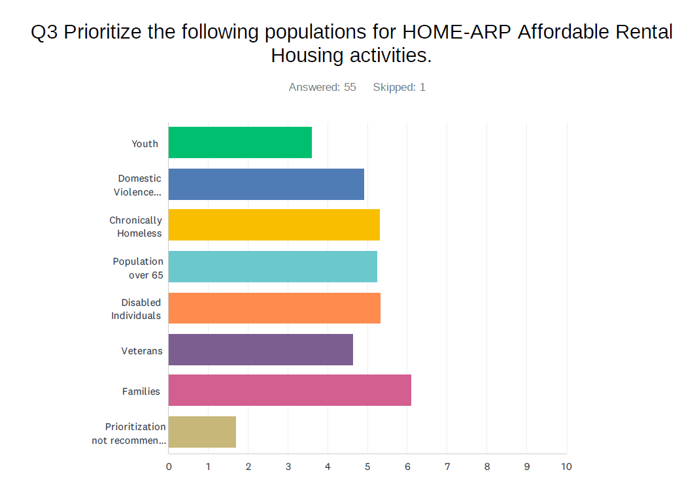

Survey Results: Housing Authorities, Community Agencies, Advisory group

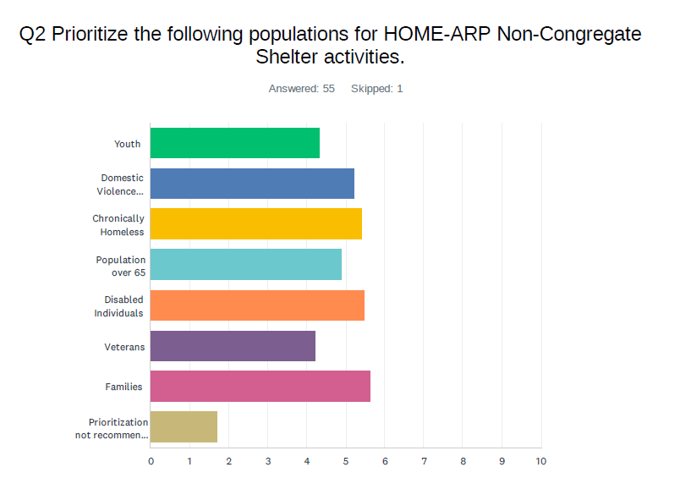

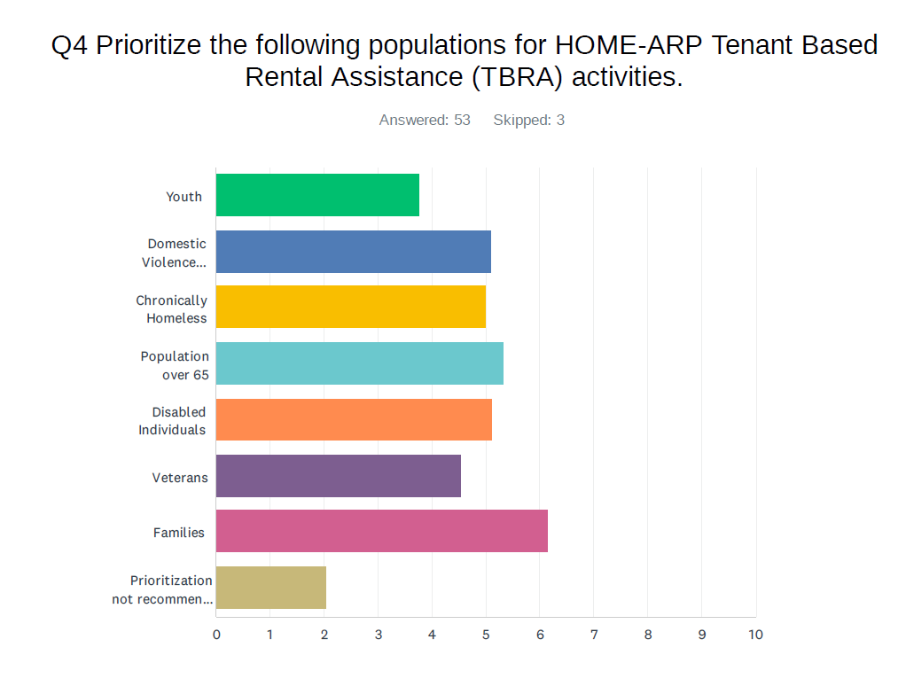

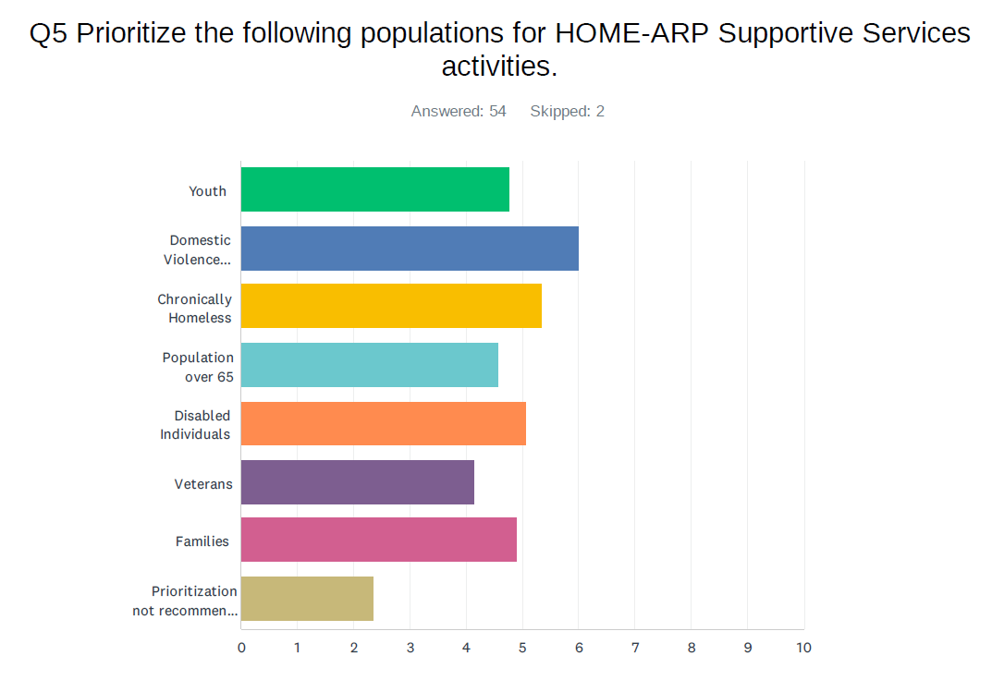

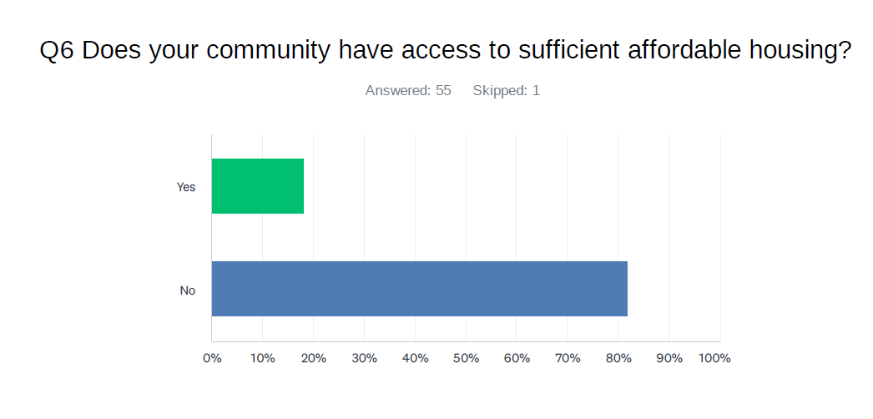

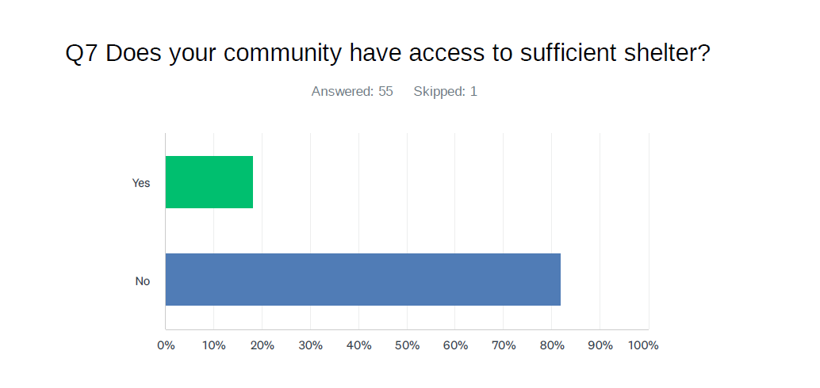

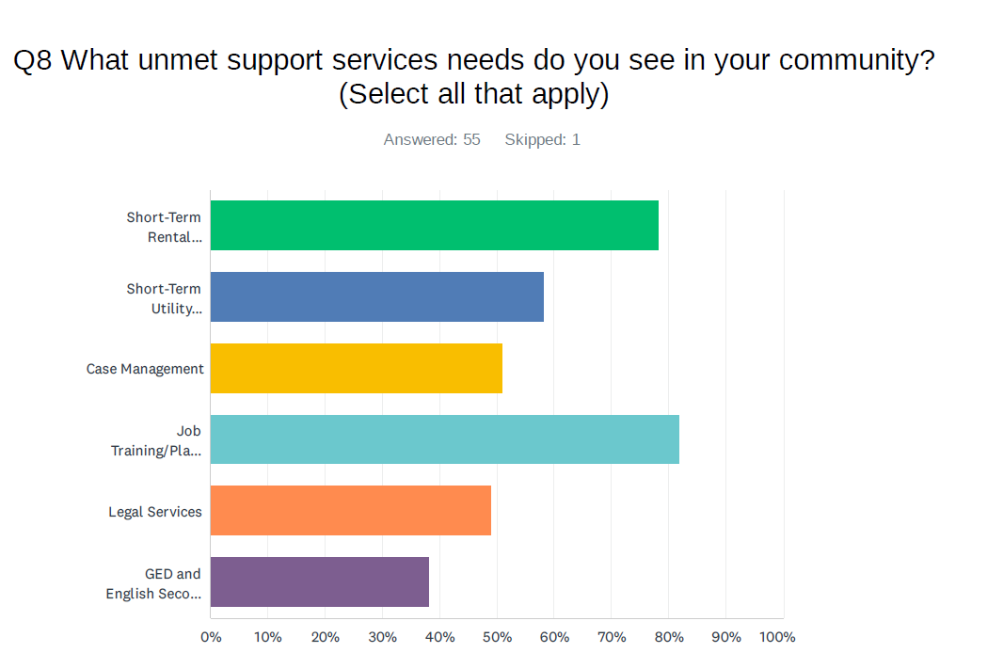

39

# APPENDIX B: Public Hearing Announcement

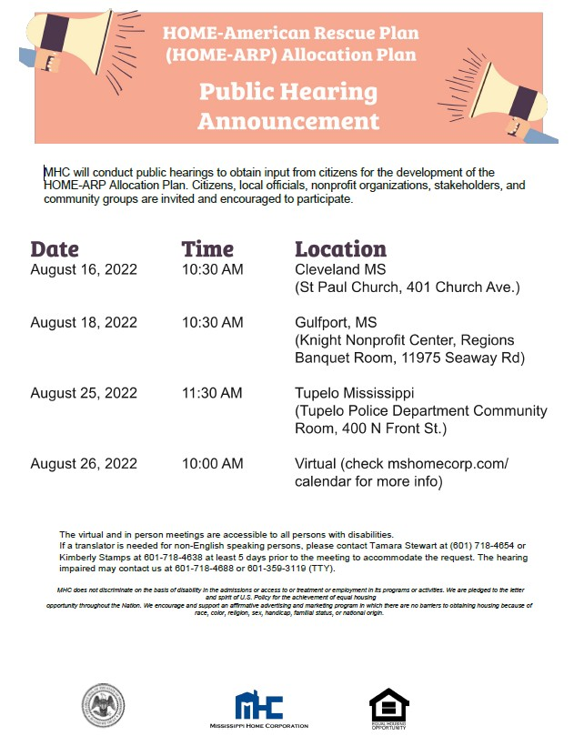

# APPENDIX C: Certifications and SF-424



See Attached